Carey Moran
Theo 375
Final
Dec 11 2017
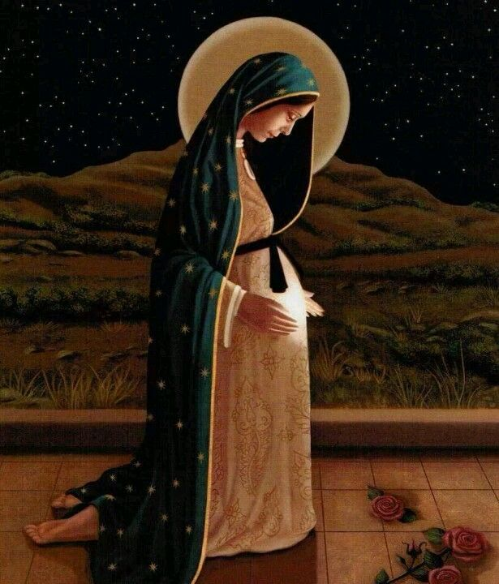
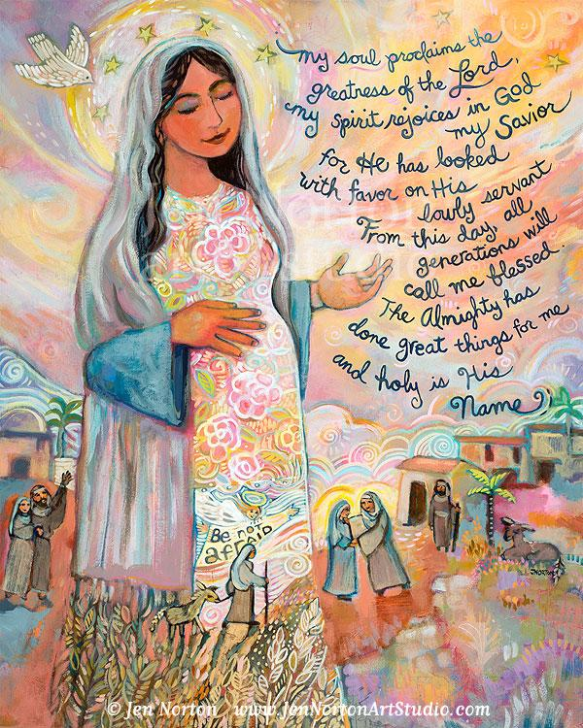

Mary’s Fiat is one of the greatest female examples we have for the Feminine Genius and what it truly means to be a woman of God, including what makes us different than men. Her willingness to say yes without knowledge of the future, shows that she knew something was special about the Christ-child whom she was to carry. In the Gospel of Luke where Mary proclaims this fiat, she says “I am the handmaiden of the Lord; let it be to me according to your Word” (Luke 1:38). We can all learn from Mary’s Fiat to say yes to things in life where you may not know what God has planned for you.
The Feast of the Annunciation and the time of the advent season are both related as we are preparing for Christ’s birth. During the nine months, between the Annunciation and Christmas, is time of Mary becoming a mother. Advent is not just the celebration of Christ’s birth, but also Mary becoming the icon that she is to us. Both images, it shows Mary being pregnant, which would of her Yes, and it also shows as she is preparing for Christ birth. Most images of the Nativity, include Joseph, the shepherds and the magi in the images, whereas these don’t explicitly show it, but yet they are showing that scene of Mary waiting.
Both of these images show the simple beauty and suddle joy that Mary took on when she said Yes for being the Mother of Christ. The image on the left, has Mary’s Canticle also known as the Magnificat, and is also has the depiction of the Christmas story. Of Mary and Joseph traveling to Bethlehem, to give birth to Jesus, we also see some of the animals that were present. I believe depicted is Mary’s cousin Elizabeth, since when Angel Gabriel told Mary she was going to have Jesus, he also told her that her cousin was expecting. I love how on her dress at the bottom there is a image of the angel, that says Be Not afraid.
Then the image on the right, has a simply beauty to it because it is Mary adorning and gazing upon her child within her, that knows that she is doing something that is a once in a lifetime worldly thing to have happen. We can say that Mary was truly the original tabernacle, she had Christ within her for 9 months. This image to me imitates and represents what that would look like. All of it would have such beauty but Christ being the focus and the center of attention. Archbishop Fulton Sheen once described the Blessed Mother as “a magnifying glass that intensifies our love of her Son.” (The Magnificat). That through Mary, we learn to have a greater love for her son.
St. John Paul the Great once said “From Mary we learn to surrender to God’s will in all things. From Mary we learn to trust even when all hope seems gone. From Mary we learn to love Christ her son and the Son of God!” Mary surrendered to what God had planned for her, she trusted that all would be okay, being that she was an unwed young women, in a society where that was not the norm. We learn to love her son, we see by her example that she was with him through it all. She helped raised him, and she was with him until the end, and was there at the resurrection. Mary isn’t just a model for women, but a model of faith for all.
“Mary is no doubt the Queen, the prime model of faith and cooperation with grace. But she is that model not simply because of who she is, but because of who God is and how she permitted Him to work in her life. The beautiful thing about Mary is that she didn’t need to do anything but trust in God and act in faith in order to bring our savior into the world. In the same way, we don’t need to do anything wildly monumental when it comes to living out God’s will in our lives; we simply need to trust that God will do the wildly monumental things in and through us and respond to His will through our words and deeds.” (Murphy, 31)
We can echo her Yes, by giving full faith and trust into God in what he has planned for us.
It’s interesting how Mary is respected across cultures and religions, for the most part, while some Christian religions don’t fully understand her fully beauty and grace, still respect her. Since she is respected for being the mother of Christ and not always for women and their full beauty. And yet we still see women’ understanding of self shifted and mixed based on what society tells them what they should be like and understanding of their body.
Some people slander that women are taken advantage of, of just being baby making machines, that is just their main role in society, or we have people who would say that women can do more than just have children and be a mom. But if you truly understand that beauty that we have been given the gift to bare children, then we would have a greater respect and understanding for being a women and being a mother. There is so much more to understanding of what being women entails.
Our Church is filled with so many saints, who had great devotions to Mary, our Mother. They came to know through her, her son, our savior. That through her love and devotion to Him, she lead by a great example to us of faith, humility, courage and so much more. We don’t worship Mary, but we do pray to her. And for very good reasons. Like at the Wedding Feast at Cana, Jesus’ first miracle is done by in response to Mary’s intercession. “Jesus’ response shows he thinks Mary knows perfectly well what is going on: He’s the Messiah and she wants him to manifest himself to Israel.” (Shea, 2012)

Work Cited

Murphy, Leah. “The Power of Peace.” Awaken Hope: Reflections on the Season of Advent, Life
Teen, 2017, pp. 11–36.

Shea, Mark. “The Significance of the Wedding at Cana.” National Catholic Register, EWTN, 9
Sept. 2012,
www.ncregister.com/blog/mark-shea/the-significance-of-the-wedding-at-cana.

“THE MAGNIFICAT.” The Magnificat: Mary's Hymn of Praise for Our Lord, Our Catholic
Prayers, 2017, www.ourcatholicprayers.com/magnificat.html.

